Bahria University,

Karachi Campus



LAB EXPERIMENT NO.

6

LIST OF TASKS

|  |  |
| --- | --- |
| TASK NO | OBJECTIVE |
| 1 | Take 4 switches named as: A, B, C, D and connect them in alphabetical order. Perform and show the following configurations in your lab task: a. Switch A with VLANs faculty and students having 1 logical port each. b. Now assign 1 logical port each to VLANs faculty and students in Switch B and D. c. Now make switch A in server mode, whereas B and D in client mode and switch C in transparent mode. d. Assign IP addresses to PCs connected to Switch A, B and D. e. Now ping within the same VLAN and outside the same VLAN and show your results. |

Submitted On:

2-Nov-2023

(Date: DD/MM/YYYY)

**TASK 01**

Take 4 switches named as: A, B, C, D and connect them in alphabetical order. Perform and show the following configurations in your lab task: a. Switch A with VLANs faculty and students having 1 logical port each. b. Now assign 1 logical port each to VLANs faculty and students in Switch B and D. c. Now make switch A in server mode, whereas B and D in client mode and switch C in transparent mode. d. Assign IP addresses to PCs connected to Switch A, B and D. e. Now ping within the same VLAN and outside the same VLAN and show your results.

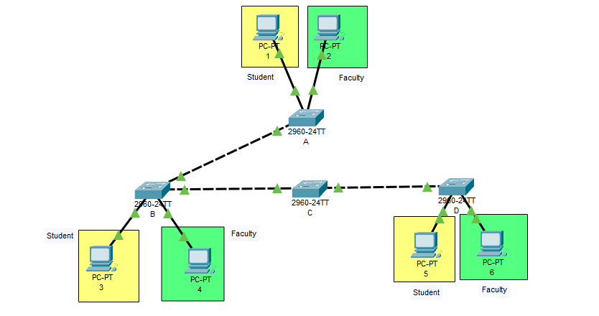

**MAKING SWITCH A SERVER MODE**

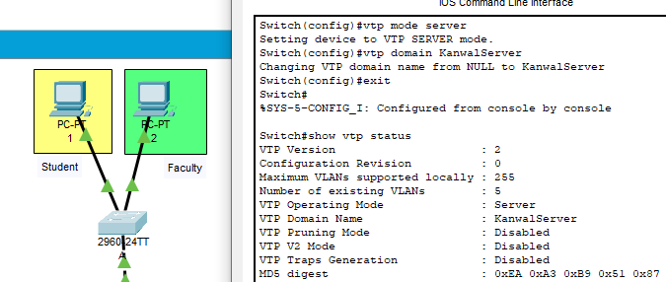

**MAKING SWITCH B CLIENT MODE**

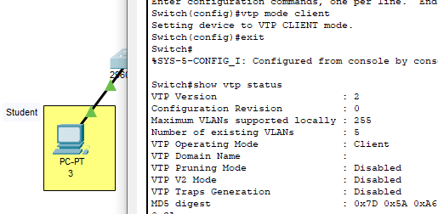

**MAKING SWITCH D CLIENT MODE**

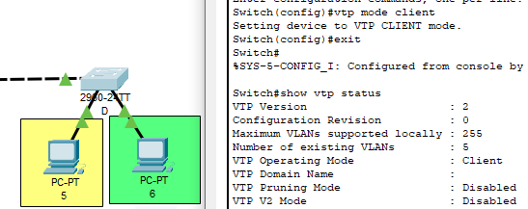

**MAKING SWITCH C TRANSPARENT MODE**

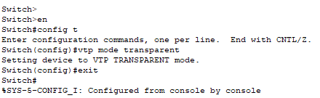

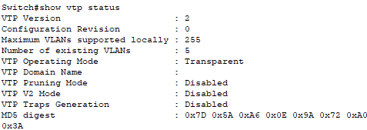

**TRUNKING**

**A TO B**

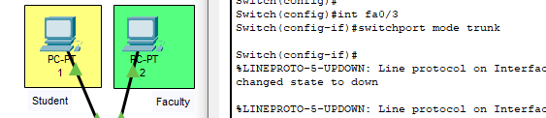

**B TO A**

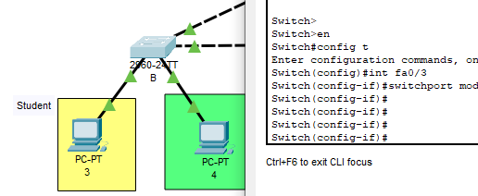

**CHECKING B**

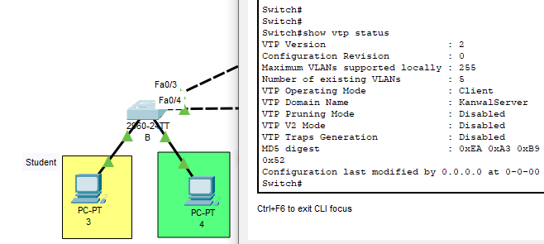

**B TO C**

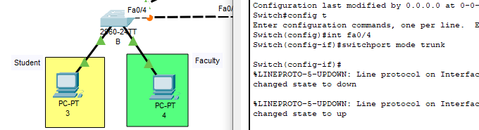

**C TO B**

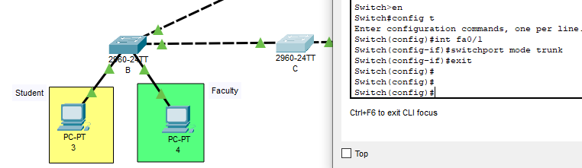

**CHECKING C**

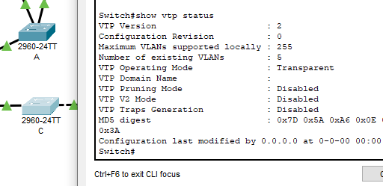

**C TO D**

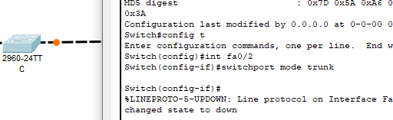

**D TO C**

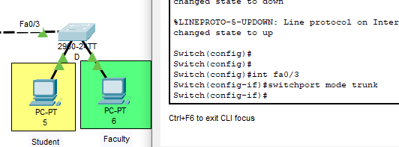

**CHECKING D**

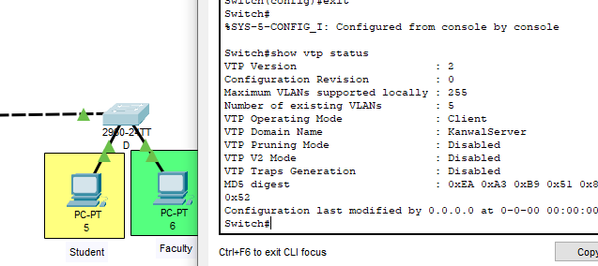

**SETTING VLAN IN A**

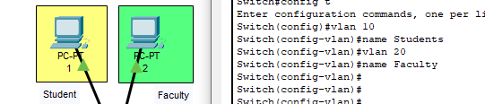

**CHECKING VLAN IN B**

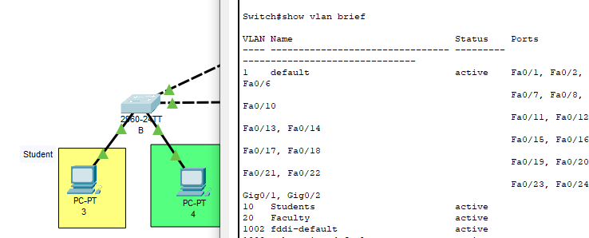

**CHECKING VLAN IN C BUT NO VLAN HERE SINCE IT IS TRANSPARENT**

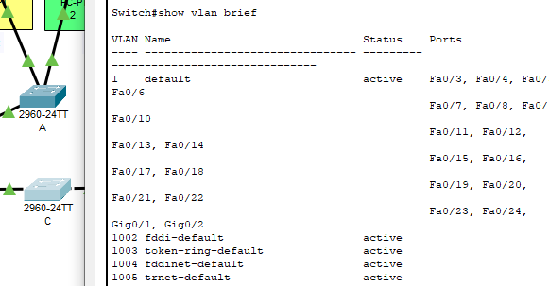

**CHECKING VLAN IN D**

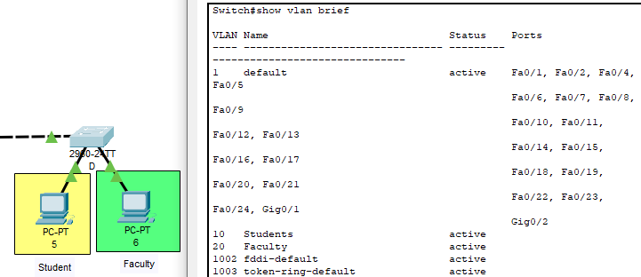

**CONFIGURING SWITCH A**

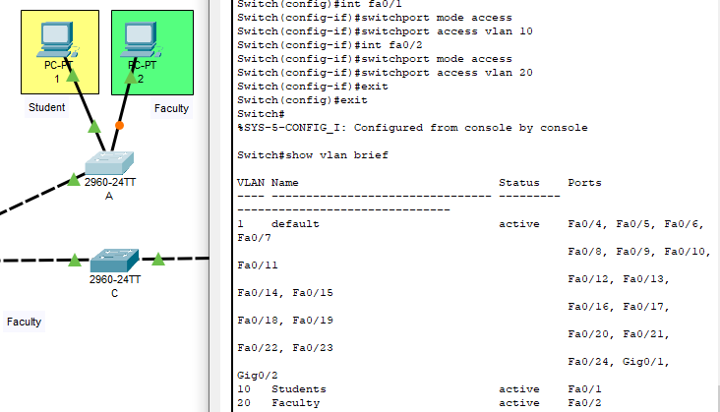

**CONFIGURING SWITCH B**

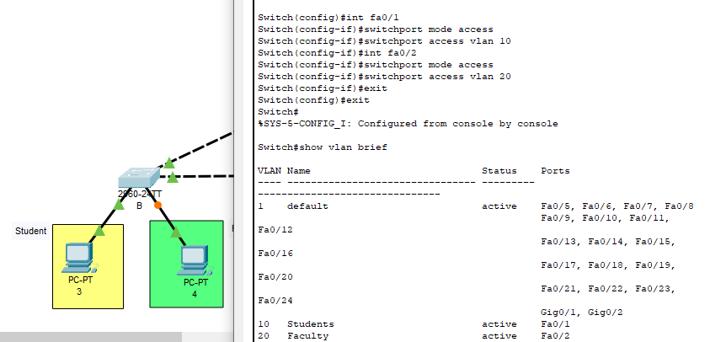

**CONFIGURING SWITCH D**

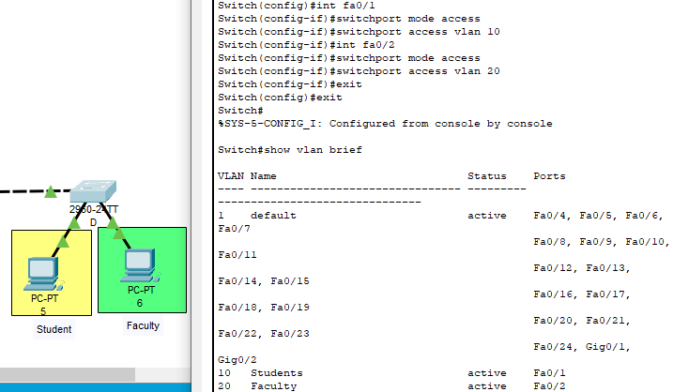

1. **Client1(Fac) to Server(Fac) = Ping**

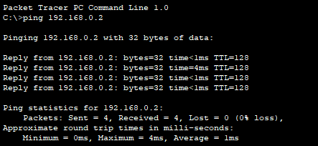

1. **Client1(Stud) to Client1(Fac) = Failed**

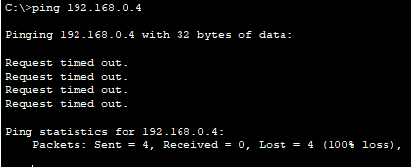

1. **Server(Stud) to Client1(Stud) = Ping**

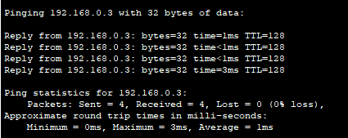

1. **Anywhere to Client2 = Failed**

